HW2 Route Finding

0616098 黃秉茂

prerequisite

Import modules and read csv

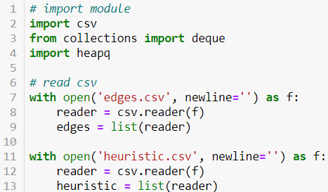

csv for read csv

deque for queue and stack

heapq for priority queue

read csv and store to lists of list.

Part 1

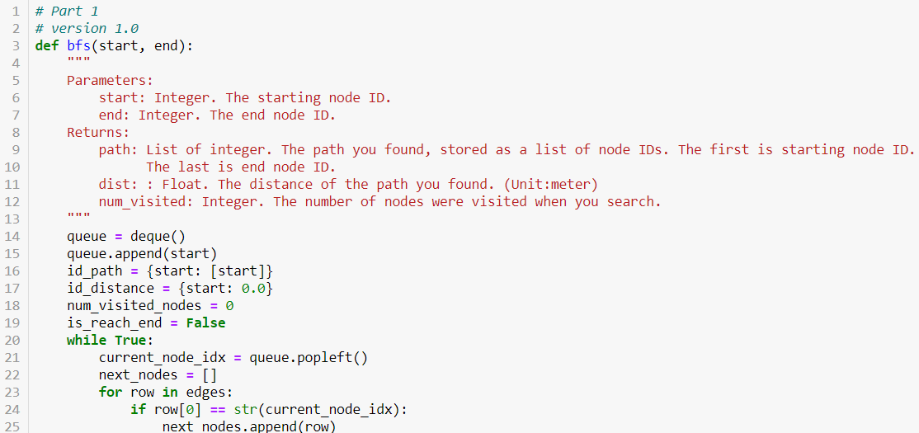

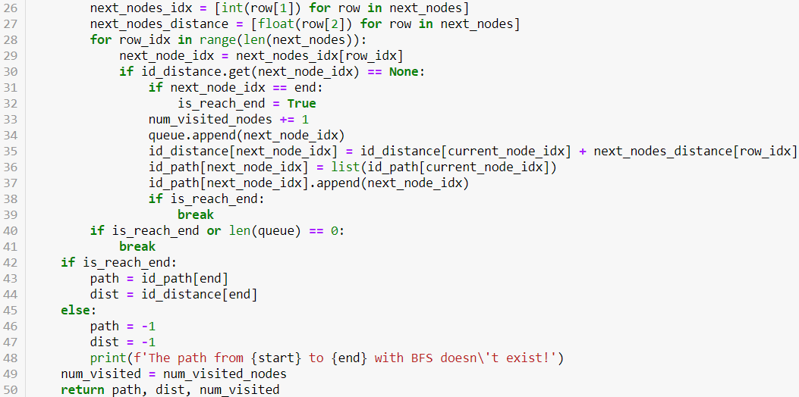

Complete bfs with queue (implemented by deque)

queue is only with the starting point first.

id_path is a dictionary which record the path to the node with id.

id_path[a] can get the path from the starting point to node a.

id_distance is a dictionary which records the distance from starting point to the node with index.

id_distance [a] can get the distance from the starting point to node a.

is_reach_end marks the end point is reach or not and the time to break from loop.

num_visited_nodes is a value which record the number of the visited value. It begins with zero and plus one when the new node is visited.

The current node is popped from queue, which is the node we are visiting, and then find the following nodes by the current node.

Getting following nodes by search in lists of list with starting point.

Getting following nodes index and distance from lists of following nodes.

After adding the distance from the starting point to the current node and the distance between the current nodes and the following nodes, record it and push the value to id_distance.

Append following node to the path from the starting point to the current node, and record it and push the value to id_path.

And then push following nodes into the queue.

id_path and id_distance are recorded a kind of recursive with the current node which attach to the following nodes.

Jump out of the loop if the end point is reached or the queue is empty.

Part 2

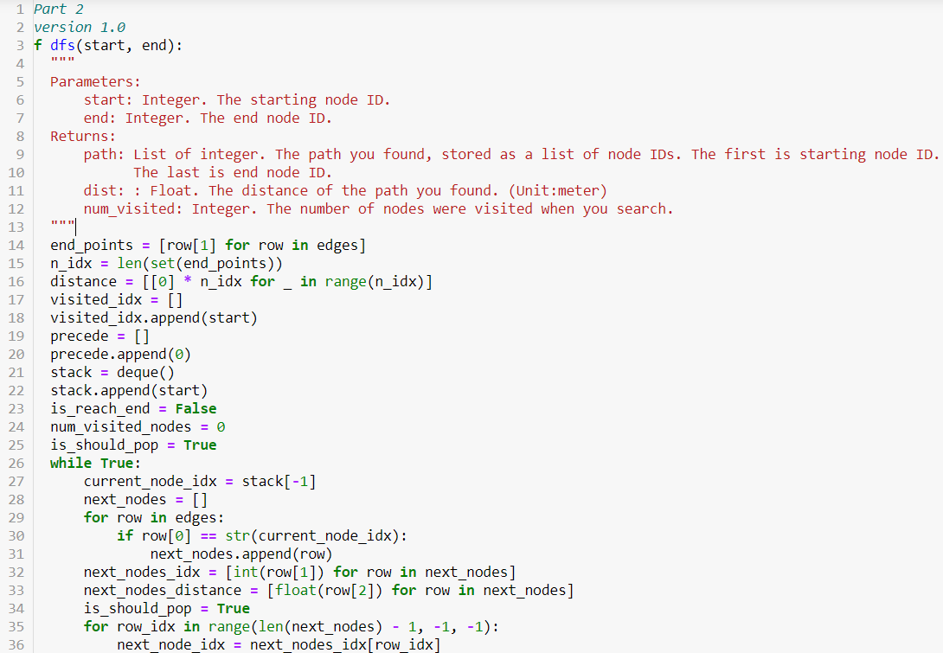

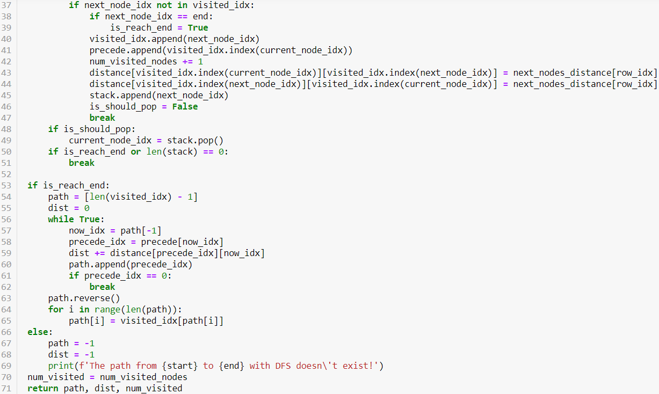

Complete dfs with stack (implemented by deque)

stack is only with the starting point first.

visit_idx is a list which recordthe nodes with index we have visited.

distance is a numpy matrix which record the distance between two nodes.

distance[i, j] can get the distance between the node I and the node j.

precede is a list which records the preceding nodes index in visit_idx.

precede[i] can get the index of preceding node i in visit_idx.

is_reach_end marks the end point is reach or not and the time to break from loop.

is_should_pop marks the stack should pop or not. It should pop something when the all following nodes are visited.

num_visited_nodes is a value which record the number of the visited value. It begins with zero and plus one when the new node is visited.

The current node is the top of the stack, which is the node we are visiting, and then find the following nodes by the current node.

Getting following nodes by search in lists of list with starting point.

Getting following nodes index and distance from lists of following nodes.

The former node it is in the lists, the latter we push into the stack.

After visiting a node, add the node to the list visit_idx and add its preceding nodes index in visit_idx to the list precede.

Record the distance between the current nodes and the following nodes to the matrix distance.

Push the following node we deal with now into the stack, and then break the loop. The other following nodes will process after we find that this following node can’t bring us to the end point.

Stack should pop something only when the all following nodes are visited.

Jump out of the loop if the end point is reached or the stack is empty.

With the list precede which records the preceding nodes index in visit_idx, we can trace the path and calculating the distance from the starting point to the end point.

From the end point, we use the list precede to get to the preceding point, and record the path and the distance between the current point and the preceding point. Recursively record the path and calculating the distance until we get to the starting point by keep tracing the preceding nodes.

Part 3

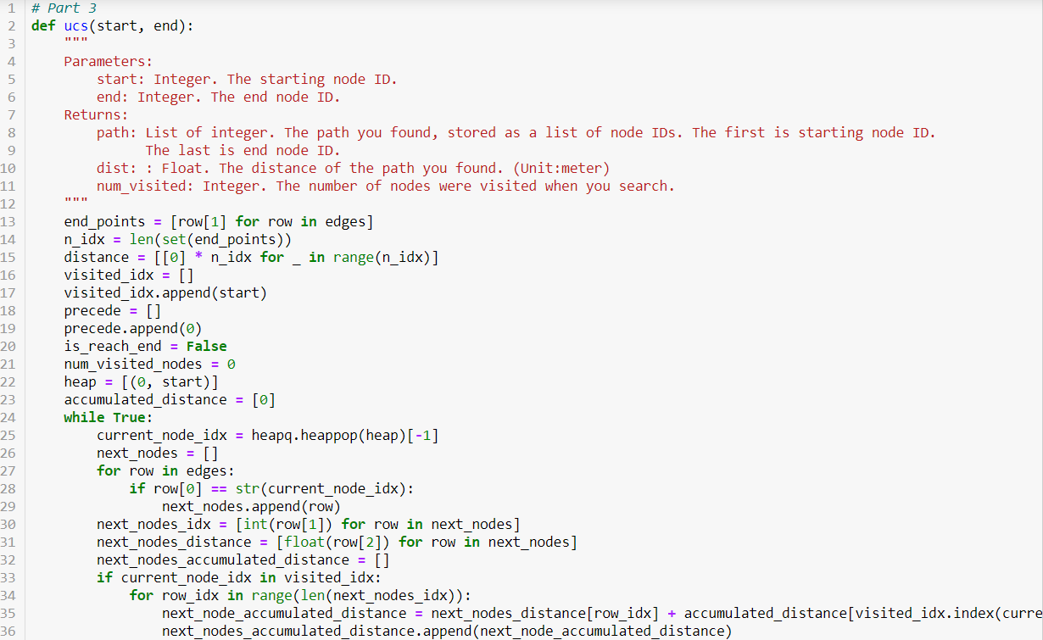

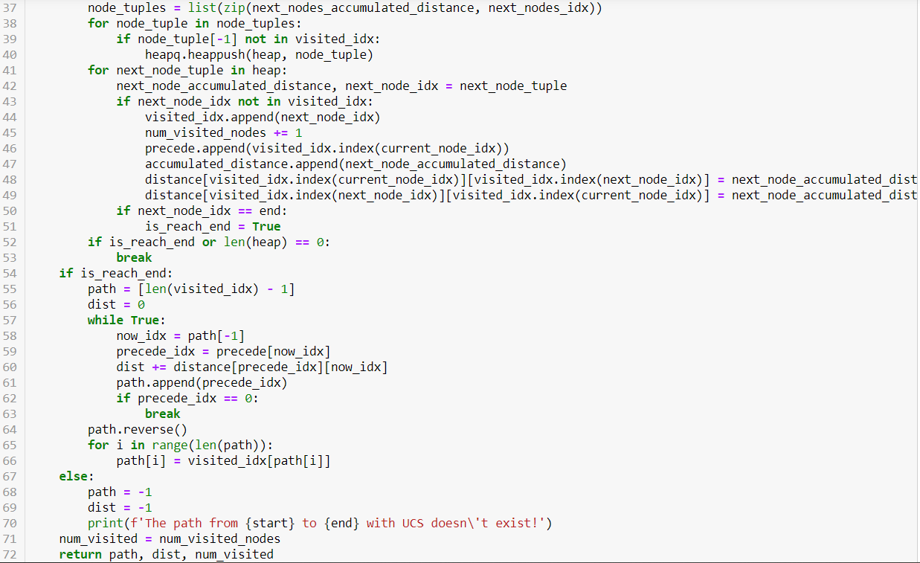

Complete ucs with priority queue (inplemented by heap)

heap is only with the starting point first.

visit_idx is a list which recordthe nodes with index we have visited.

distance is a numpy matrix which record the distance between two nodes.

distance[i, j] can get the distance between the node I and the node j.

precede is a list which records the preceding nodes index in visit_idx.

precede[i] can get the index of preceding node i in visit_idx.

accumulated_distance is a list which records the distance from the starting point to the node with index.

is_reach_end marks the end point is reach or not and the time to break from loop.

num_visited_nodes is a value which record the number of the visited value. It begins with zero and plus one when the new node is visited.

The current node is popped from heap(priority queue), which is the node we are visiting and the distance from sthe tarting point to the node with index is the least in the heap. And then find the following nodes by the current node.

Getting following nodes by search in lists of list with starting point.

Getting following nodes index and distance from lists of following nodes.

heap(priority queue) is sorted by the accumulated distance (the distance from the starting point to the node with index), so the distance is the addition of the distance from the starting point to the current node and the distance between the current node and the following node.

Push the tuple of the accumulated distance and the index of the following nodes into the heap(priority queue).

After visiting a node, add the node to the list visit_idx and add its preceding nodes index in visit_idx to the list precede.

The distance between the current nodes and the following nodes is get from the tuple in the heap(priority queue). The distance received by the tuple is accumulated, so we have to minus it with the distance accumulated to the preceding nodes.

Record the distance between the current nodes and the following nodes to the matrix distance.

Jump out of the loop if the end point is reached or the stack is empty.

With the list precede which records the preceding nodes index in visit_idx, we can trace the path and calculating the distance from the starting point to the end point.

From the end point, we use the list precede to get to the preceding point, and record the path and the distance between the current point and the preceding point. Recursively record the path and calculating the distance until we get to the starting point by keep tracing the preceding nodes.

Part 4

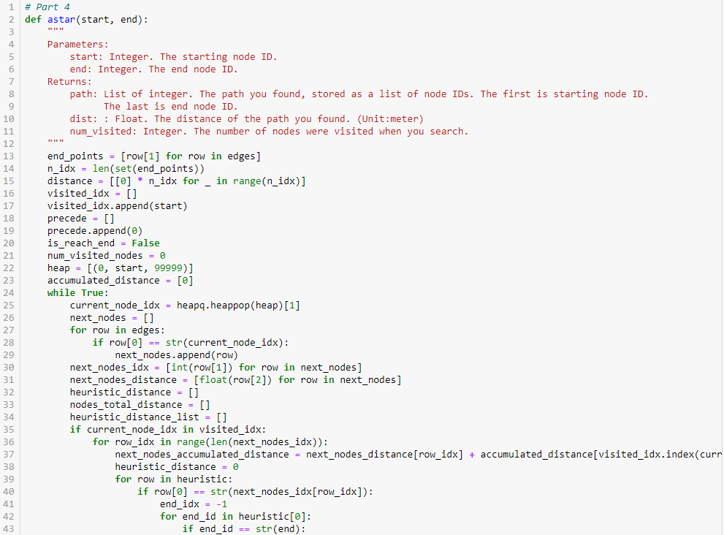

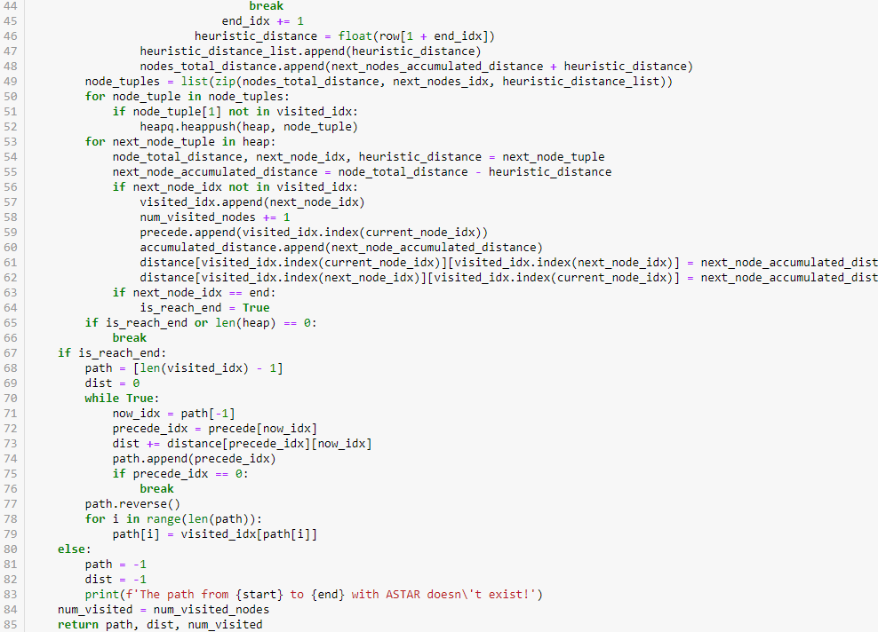

Complete A* with priority queue (inplemented by heap)

It’s implement is similar to UCS + heuristic distance.

heap(priority queue) is only with the starting point first.

visit_idx is a list which recordthe nodes with index we have visited.

distance is a numpy matrix which record the distance between two nodes.

distance[i, j] can get the distance between the node I and the node j.

precede is a list which records the preceding nodes index in visit_idx.

precede[i] can get the index of preceding node i in visit_idx.

accumulated_distance is a list which records the distance from the starting point to the node with index.

is_reach_end marks the end point is reach or not and the time to break from loop.

num_visited_nodes is a value which record the number of the visited value. It begins with zero and plus one when the new node is visited.

The current node is popped from heap(priority queue), which is the node we are visiting and the distance from sthe tarting point to the node with index is the least in the heap. And then find the following nodes by the current node.

heap(priority queue) is sorted by the total distance (the distance from the starting point to the node with index and the heuristic distance), so the distance is the addition of the distance from the starting point to the current node, the distance between the current node and the following node and the heuristic distance.

Push the tuple of the total distance, the index of the following nodes, and the heuristic distance into the heap(priority queue).

Getting following nodes by search in lists of list with starting point.

Getting following nodes index and distance from lists of following nodes.

After visiting a node, add the node to the list visit_idx and add its preceding nodes index in visit_idx to the list precede.

The distance between the current nodes and the following nodes is get from the tuple in the heap(priority queue). The distance received by the tuple is total distance, so we have to minus it with the distance accumulated to the preceding nodes and the heuristic distance.

Record the distance between current nodes and following nodes to matrix distance.

Jump out of the loop if the end point is reached or the stack is empty.

With the list precede which records the preceding nodes index in visit_idx, we can trace the path and calculating the distance from the starting point to the end point.

From the end point, we use the list precede to get to the preceding point, and record the path and the distance between the current point and the preceding point. Recursively record the path and calculating the distance until we get to the starting point by keep tracing the preceding nodes.

Part 5

Screenshot

starting node: 2270143902 end node: 1079387396

BFS

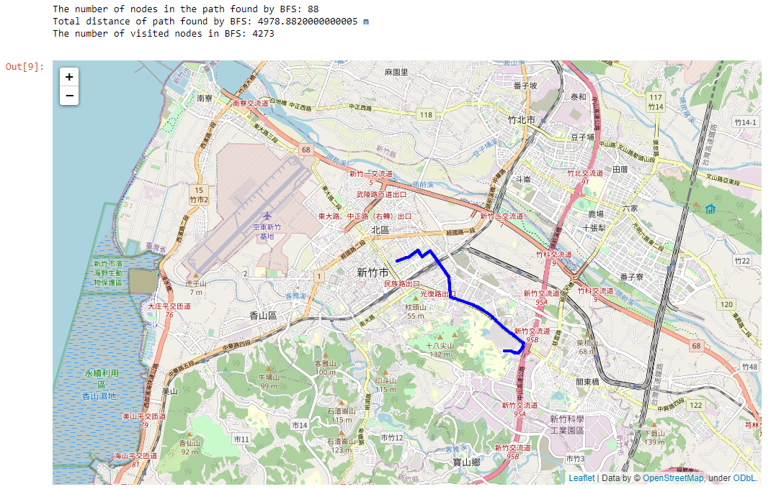

DFS

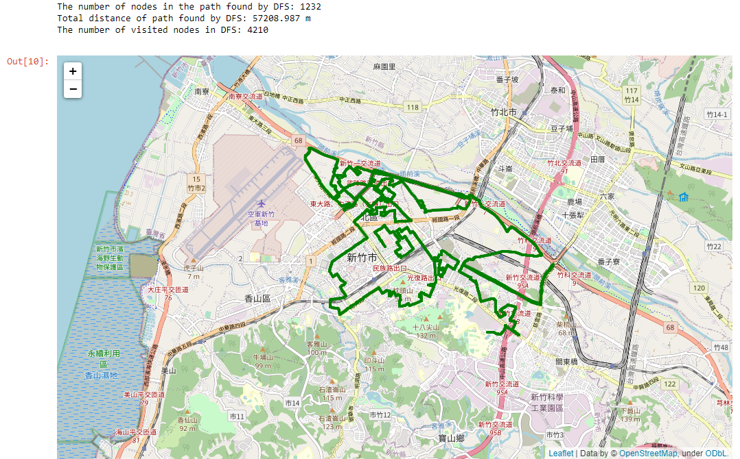

UCS

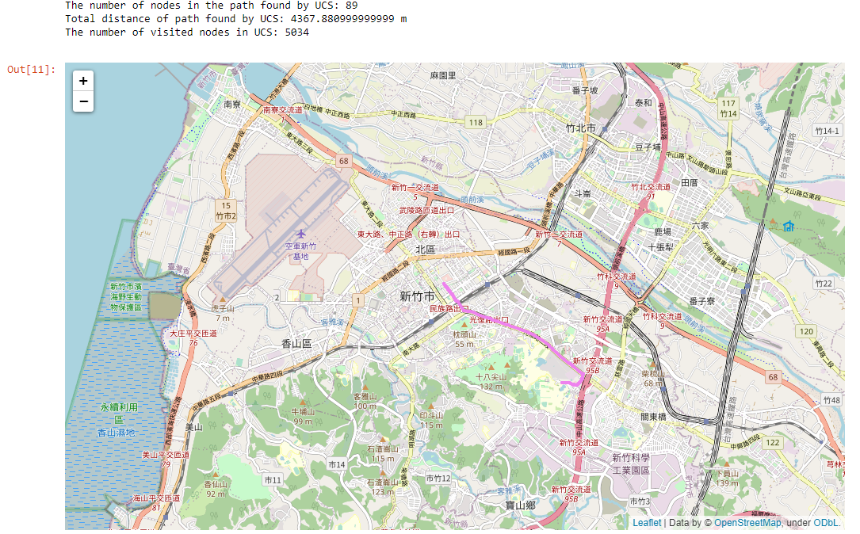

A*

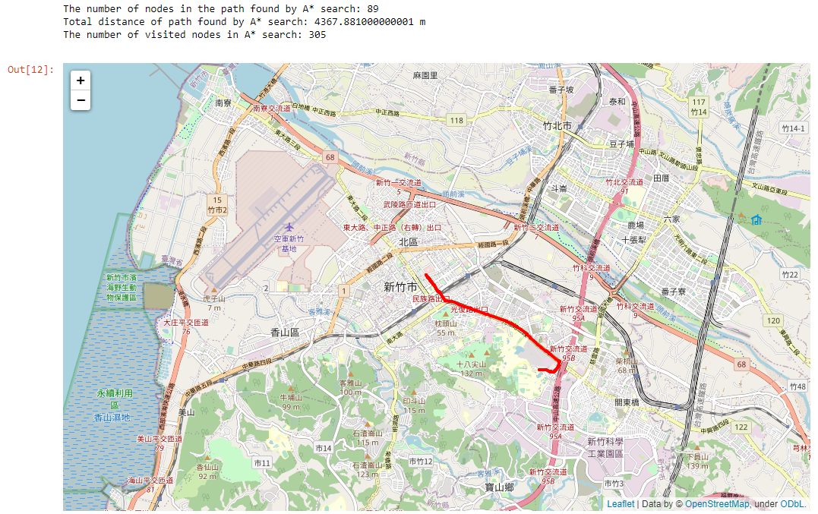

starting node: 426882161 end node: 1737223506

BFS

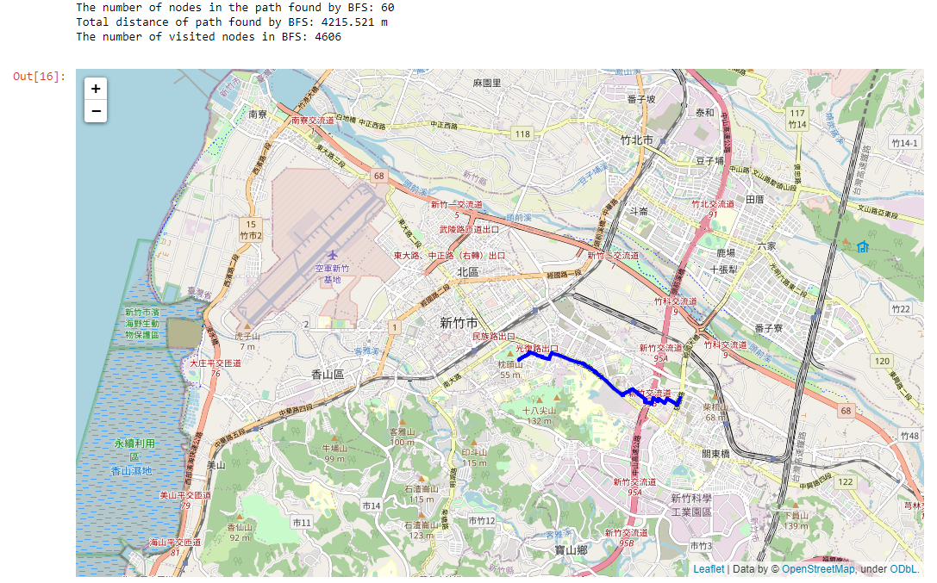

DFS

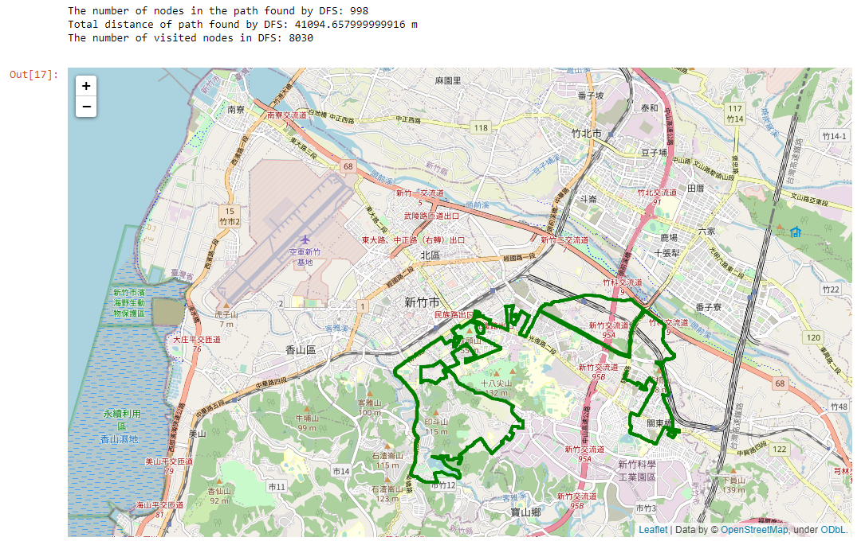

UCS

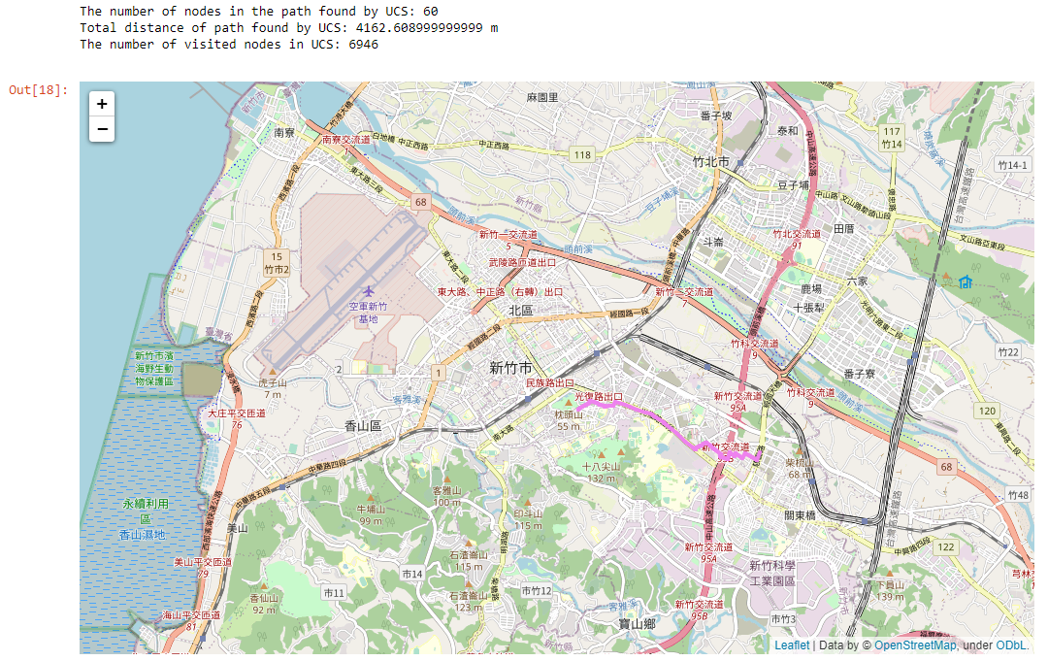

A*

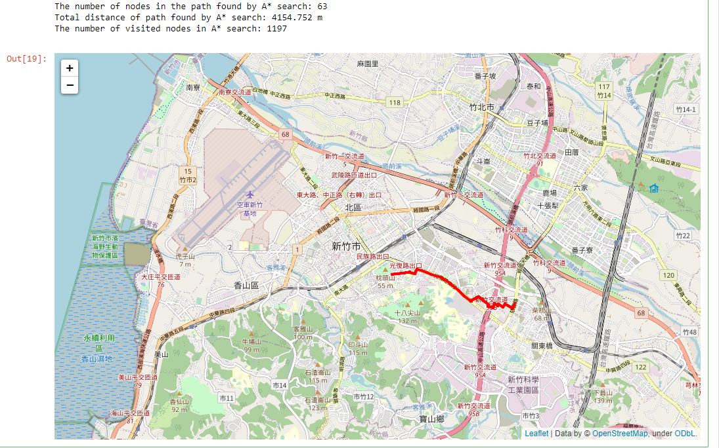

starting node: 1718165260 end node: 8513026827

BFS

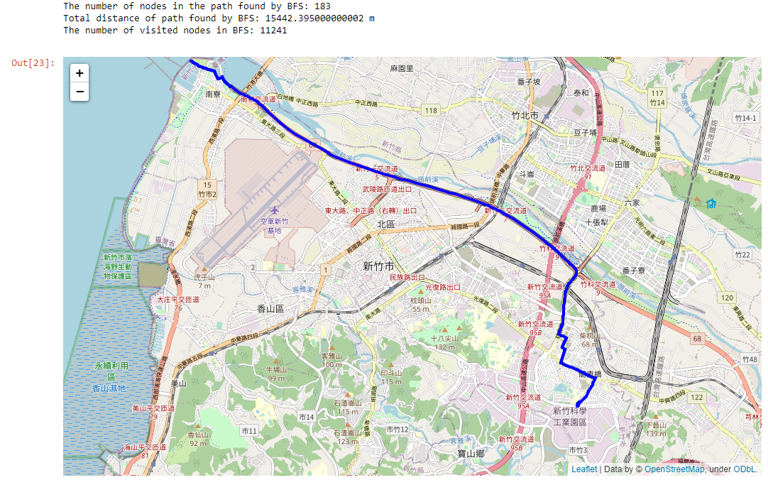

DFS

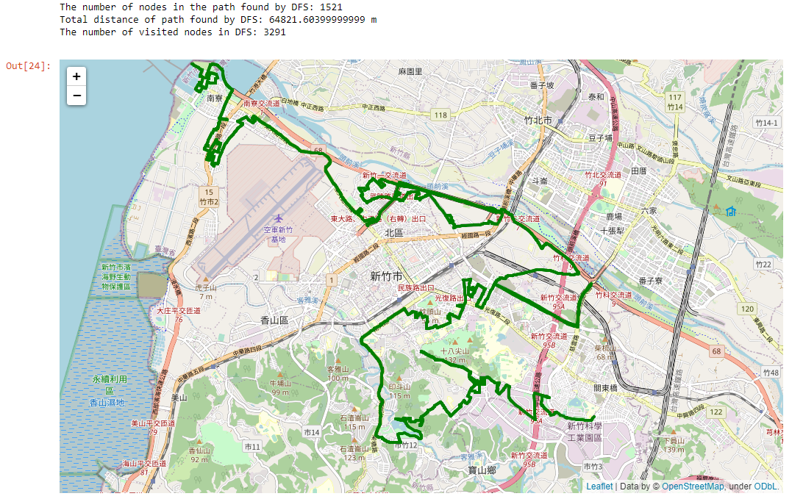

UCS

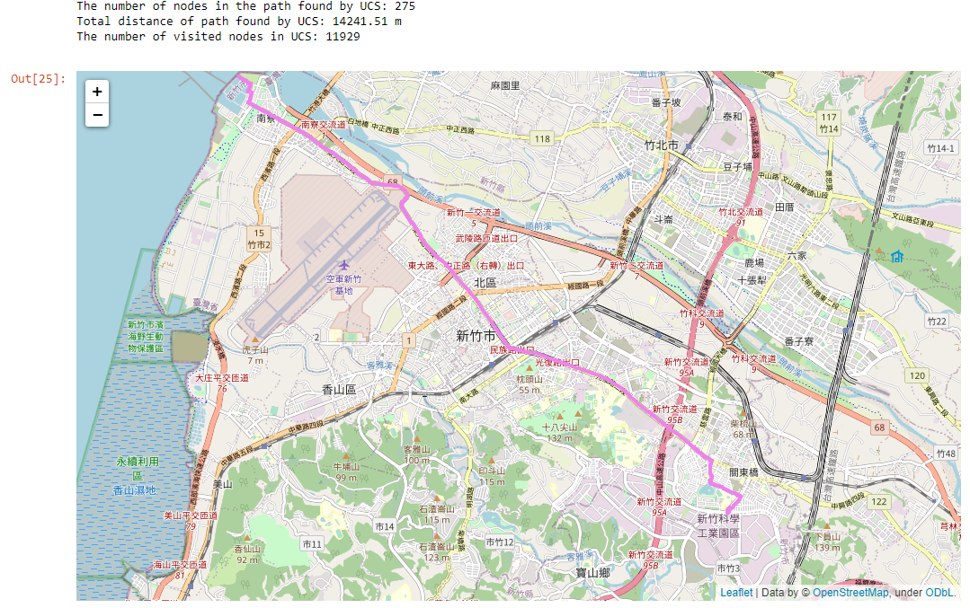

A*

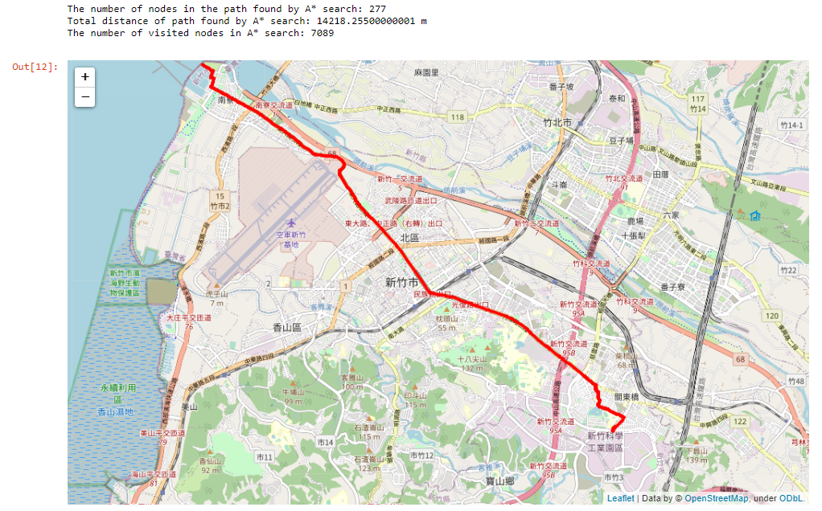

table comparison

starting node: 2270143902 end node: 1079387396

|  |  |  |  |
| --- | --- | --- | --- |
|  | # nodes in path | distance (m) | # visited |
| BFS | 88 | 4978.882 | 4273 |
| DFS | 1232 | 57208.987 | 4210 |
| UCS | 89 | 4367.881 | 5034 |
| A* | 89 | 4367.881 | 305 |

starting node: 426882161 end node: 1737223506

|  |  |  |  |
| --- | --- | --- | --- |
|  | # nodes in path | distance (m) | # visited |
| BFS | 60 | 4215.521 | 4606 |
| DFS | 998 | 41094.658 | 8030 |
| UCS | 60 | 4162.609 | 6946 |
| A* | 63 | 4154.752 | 1197 |

starting node: 1718165260 end node: 8513026827

|  |  |  |  |
| --- | --- | --- | --- |
|  | # nodes in path | distance (m) | # visited |
| BFS | 183 | 15442.395 | 11241 |
| DFS | 1521 | 64821.604 | 3291 |
| UCS | 275 | 14241.51 | 11929 |
| A* | 277 | 14218.255 | 7089 |

The most # nodes in path is always in DFS.

The least distance is always in A*.

Compare with UCS, A* is often more efficient and better performance. In other words, A* beat UCS.

In some conditions, DFS can be the most efficient. However, DFS always lead to the worst performance not only # nodes in path but also distance

The performance in BFS, UCS, and A* doesn’t differ a lot.

Part 6

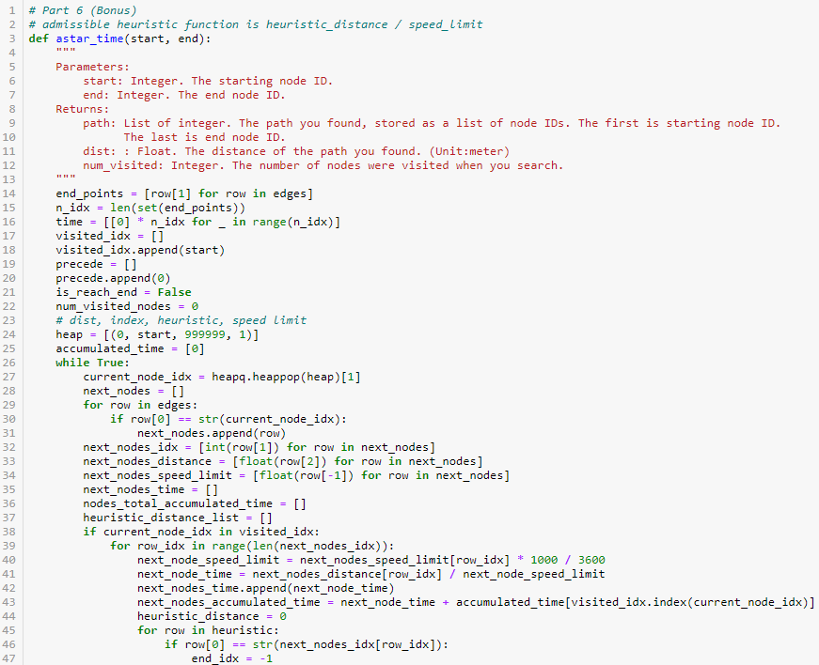

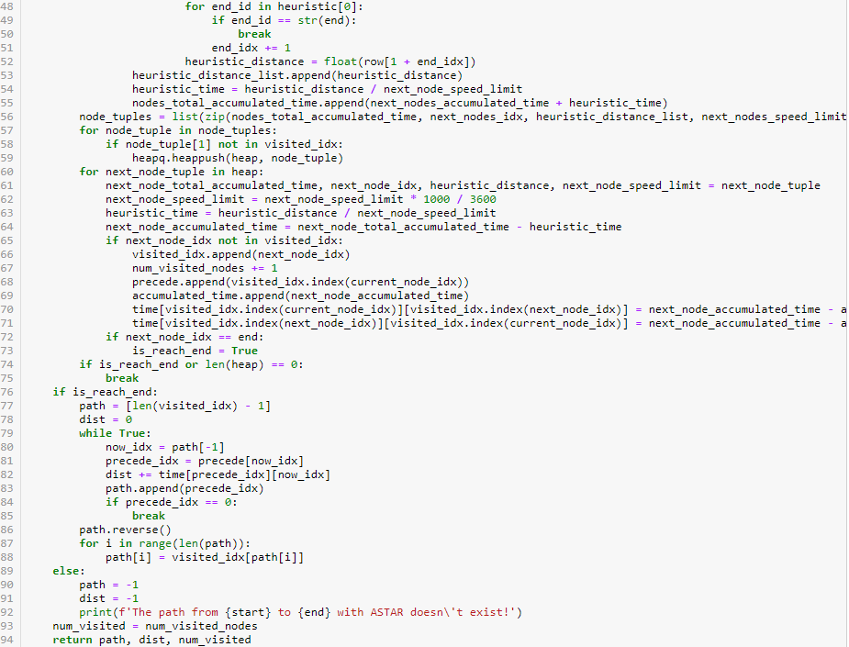

Complete A* time with priority queue (inplemented by heap)

It’s implement is similar to A* and change distance to time.

admissible heuristic function is heuristic distance divide the speed limit.

heap(priority queue) is only with the starting point first.

visit_idx is a list which recordthe nodes with index we have visited.

time is a numpy matrix which record the time you take between two nodes.

time[i, j] can get the time you take between the node I and the node j.

precede is a list which records the preceding nodes index in visit_idx.

precede[i] can get the index of preceding node i in visit_idx.

accumulated_time is a list which records the time from the starting point to the node with index.

is_reach_end marks the end point is reach or not and the time to break from loop.

num_visited_nodes is a value which record the number of the visited value. It begins with zero and plus one when the new node is visited.

The current node is popped from heap(priority queue), which is the node we are visiting and the time from the starting point to the node with index is the least in the heap. And then find the following nodes by the current node.

heap(priority queue) is sorted by the total time (the time from the starting point to the node with index and the heuristic time), so the time is the addition of the time from the starting point to the current node, the time between the current node and the following node and the heuristic time.

All the time is the distance divide the speed limit.

Push the tuple of the total time, the index of the following nodes, the heuristic distance, and the speed limit into the heap(priority queue).

Getting following nodes by search in lists of list with starting point.

After visiting a node, add the node to the list visit_idx and add its preceding nodes index in visit_idx to the list precede.

The time between the current nodes and the following nodes is get from the tuple in the heap(priority queue). The time received by the tuple is total time, so we have to minus it with the time accumulated to the preceding nodes and the heuristic time.

Record the time between current nodes and the following nodes to the matrix time.

Jump out of the loop if the end point is reached or the stack is empty.

With the list precede which records the preceding nodes index in visit_idx, we can trace the path and calculating the time from the starting point to the end point.

From the end point, we use the list precede to get to the preceding point, and record the path and the time between the current point and the preceding point. Recursively record the path and calculating the time until we get to the starting point by keep tracing the preceding nodes.

starting node: 2270143902 end node: 1079387396

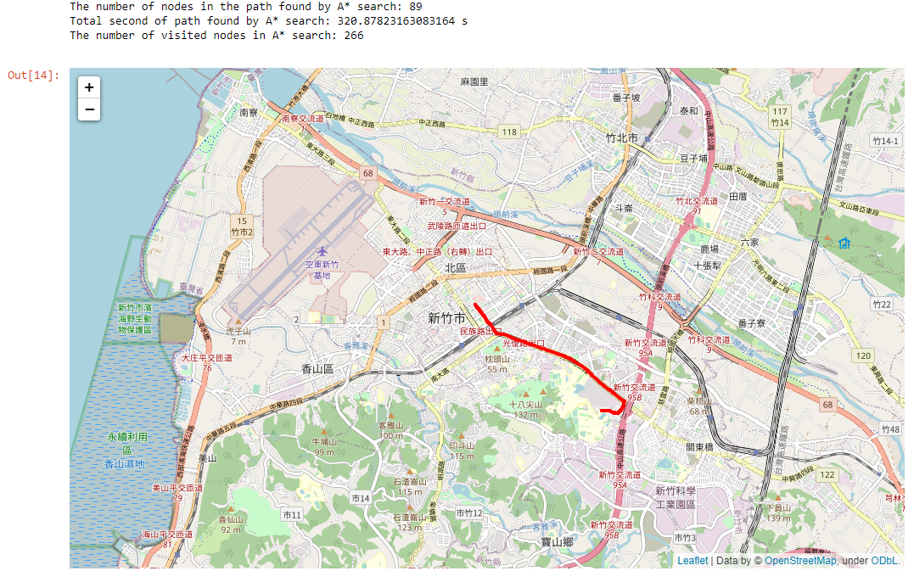

starting node: 426882161 end node: 1737223506

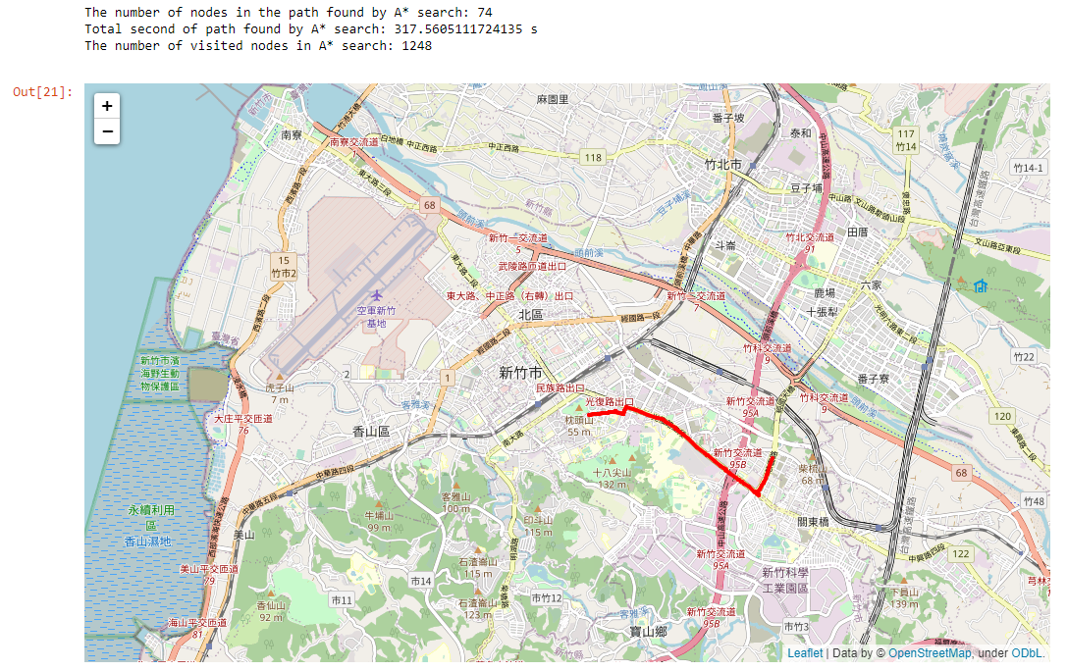

starting node: 1718165260 end node: 8513026827

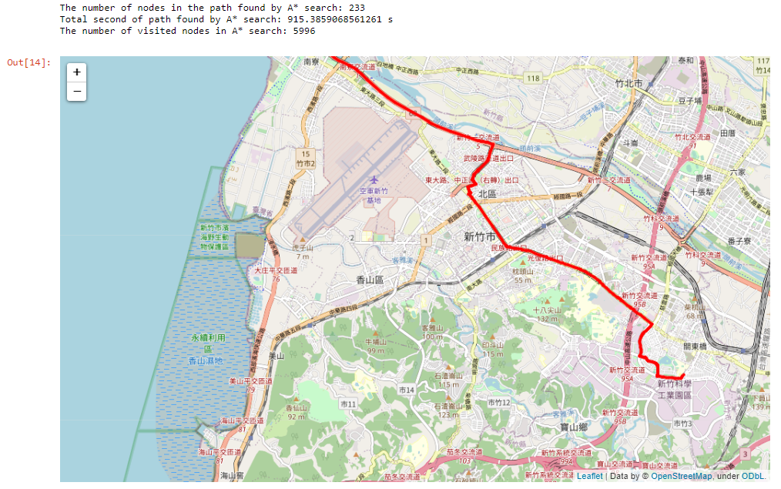

starting node: 2270143902 end node: 1079387396

|  |  |  |  |
| --- | --- | --- | --- |
|  | # nodes in path | distance (m) | # visited |
| BFS | 88 | 4978.882 | 4273 |
| DFS | 1232 | 57208.987 | 4210 |
| UCS | 89 | 4367.881 | 5034 |
| A* | 89 | 4367.881 | 305 |
| A* time | 89 | 320.8782 (s) | 266 |

starting node: 426882161 end node: 1737223506

|  |  |  |  |
| --- | --- | --- | --- |
|  | # nodes in path | distance (m) | # visited |
| BFS | 60 | 4215.521 | 4606 |
| DFS | 998 | 41094.658 | 8030 |
| UCS | 60 | 4162.609 | 6946 |
| A* | 63 | 4154.752 | 1197 |
| A* time | 74 | 317.5605 (s) | 1248 |

starting node: 1718165260 end node: 8513026827

|  |  |  |  |
| --- | --- | --- | --- |
|  | # nodes in path | distance (m) | # visited |
| BFS | 183 | 15442.395 | 11241 |
| DFS | 1521 | 64821.604 | 3291 |
| UCS | 275 | 14241.51 | 11929 |
| A* | 277 | 14218.255 | 7089 |
| A* time | 233 | 915.3859 (s) | 5996 |

The path in A* time is similar to that in A*.

The efficiency of A* time is often beat that of A*, so I think A* time is a kind of efficient algorithm.

Describe problems you meet and how you solve them.

How to find the following nodes?

With the assist of the lists of list and find it with searching the column with specific matching values like the starting points.

Why does dfs not work when I just change the queue to the stack from bfs?

Although changing the queue to the stack from bfs, some nodes should push into the stack later. You have to push they after we recognize the node we encounter former can’t lead us to the end point instead of pushing they into the stack when we met at first.

How to create 2D array to record the distance between 2 nodes?

I first use [[0] * n] * n, but it will make some mistakes when assign some values to the element in the 2D list. Therefore, I change to use

[[0] * n for _ in range(n)]and it works.

How to record the path?

Using a list to record the preceding node of the currunt visiting node.

How to complete UCS?

BFS and priority queue, and priority queue can implemented by heapq. Moreover, you have to compare the accumulated distance.

How to calculate the accumulated distance?

With the help of the numpy 2D array which record the distance between two nodes. And record to the list.